# **Lanz Povey**

**How to Find a Missing Document on Visual Studio**

# Method 1: Finding Where you Last Saved

1. Go to File

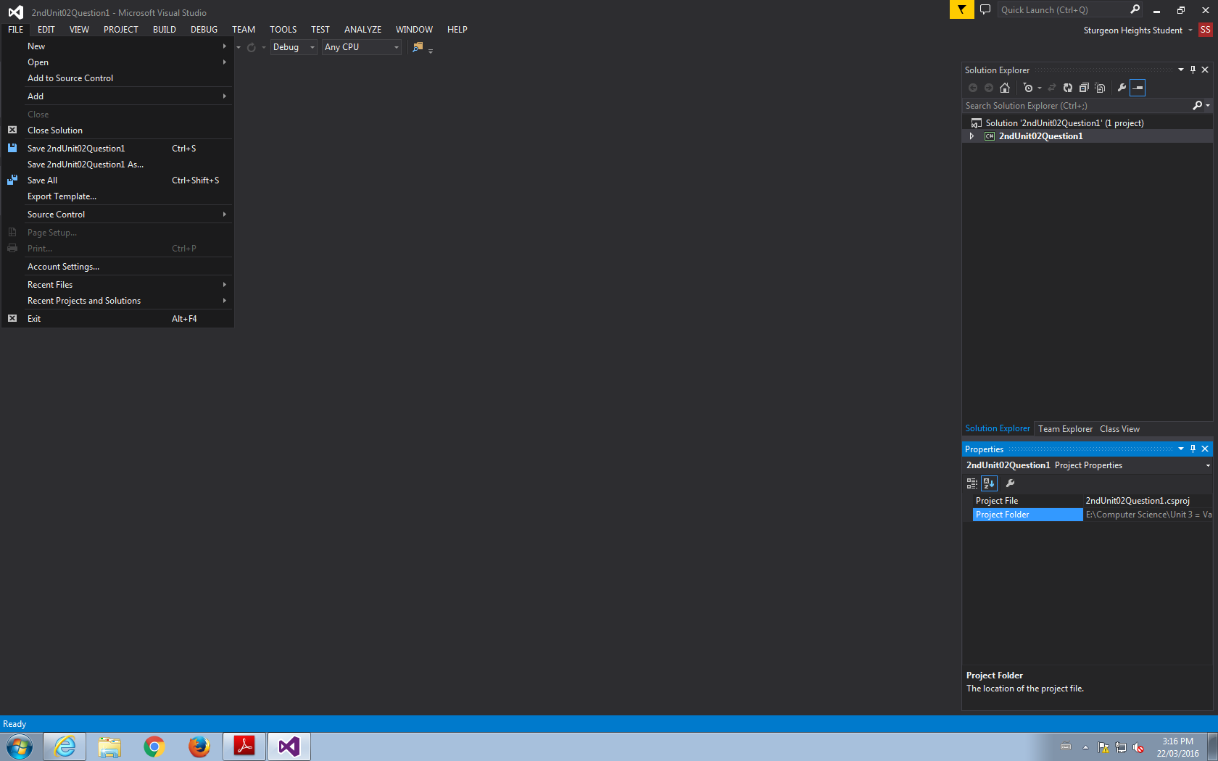

2. Go to New

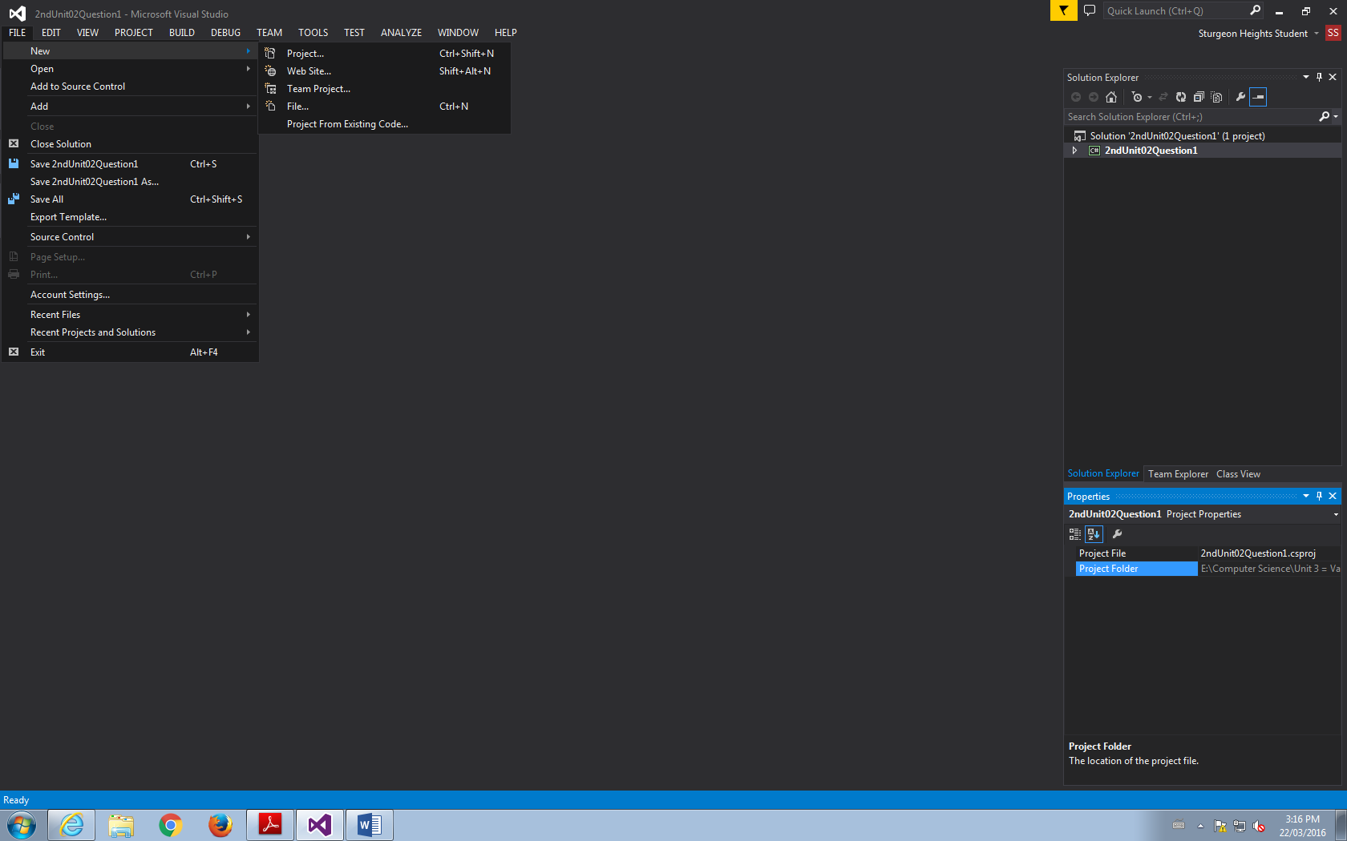

3. Go to new PROJECT, not File

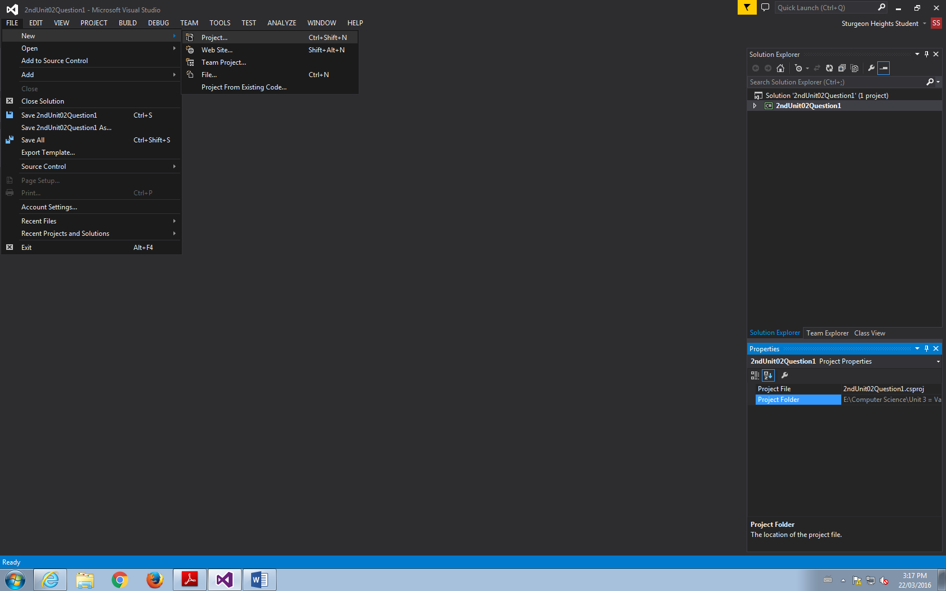

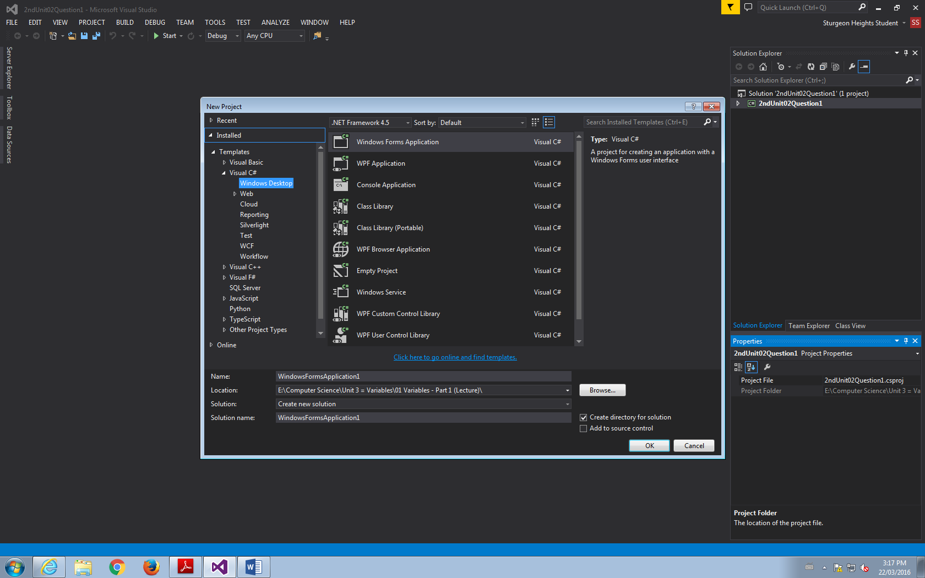

4. Go to Browse

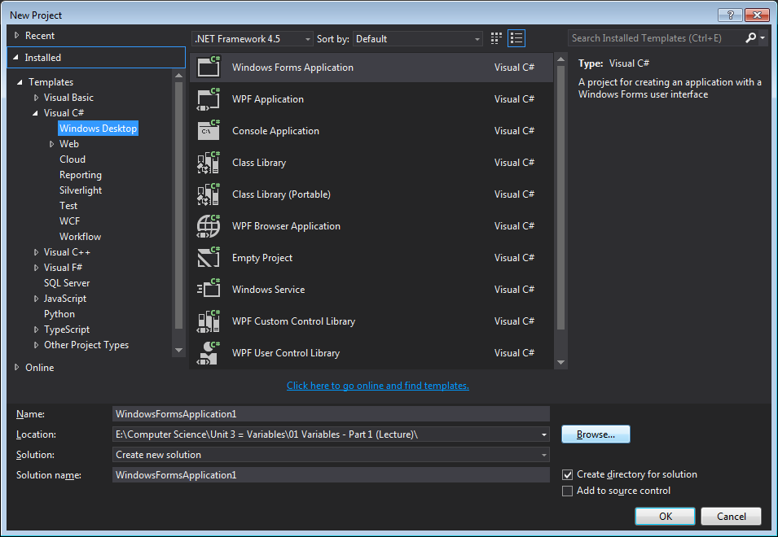

5. VOILA! Now you can see where you last saved it!

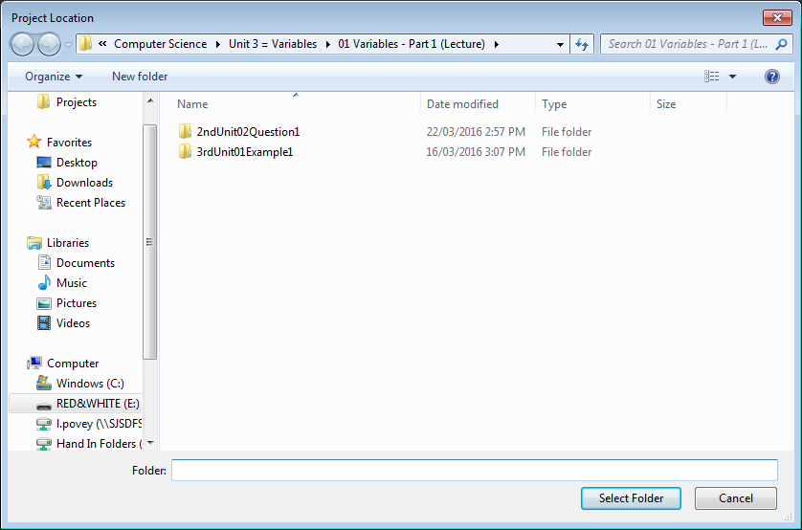

# Method 2: Checking the Properties of the File.

1. Go to File

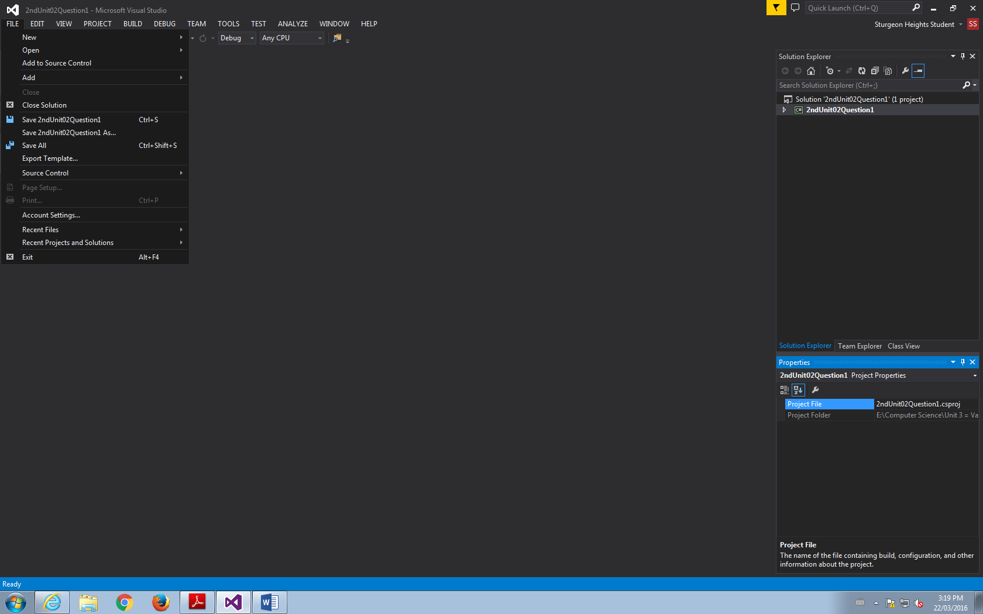

2. Go to Recent Files

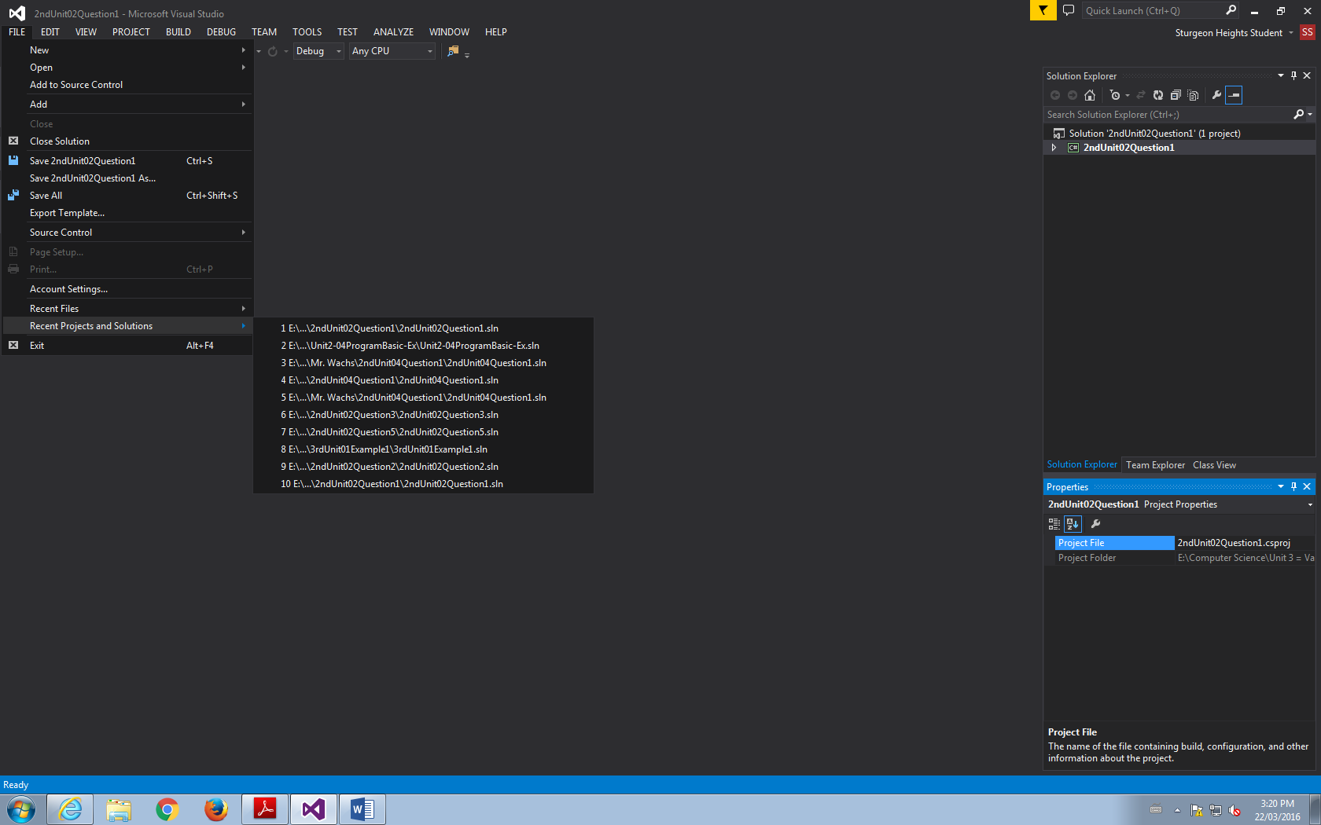

3. Go to the File that Applies to You.

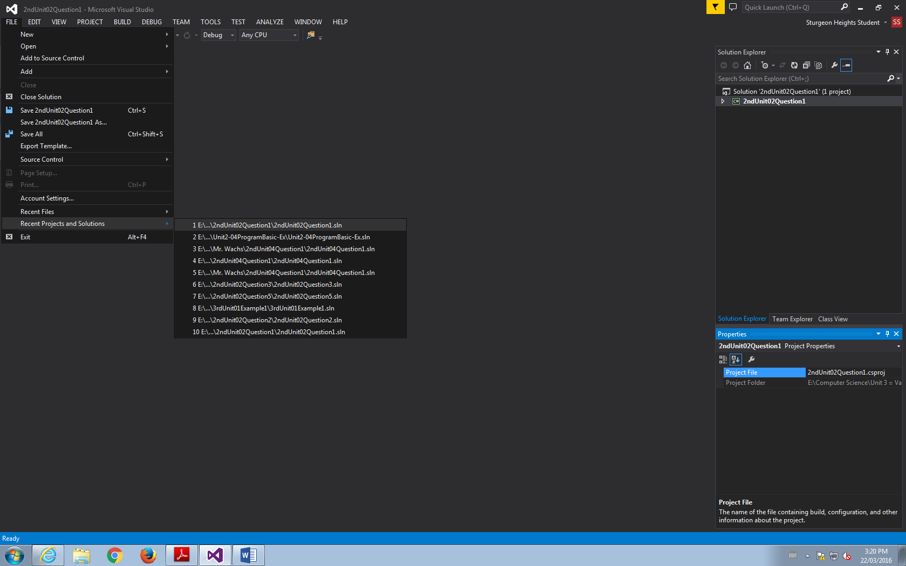

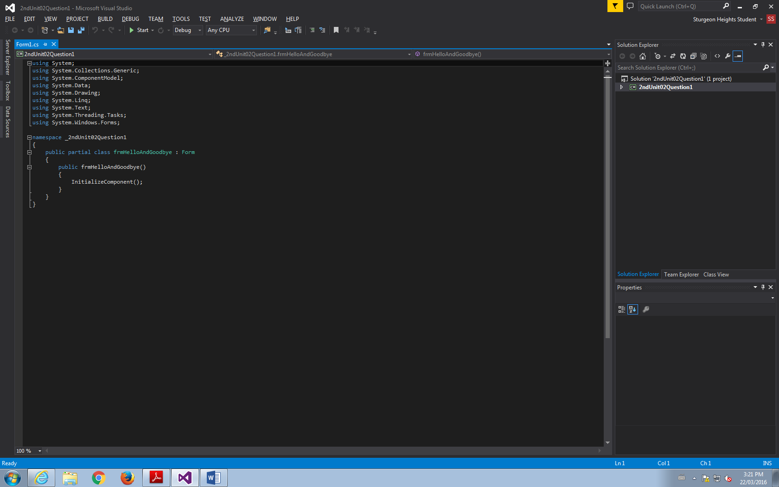

4. Close Out of the Code

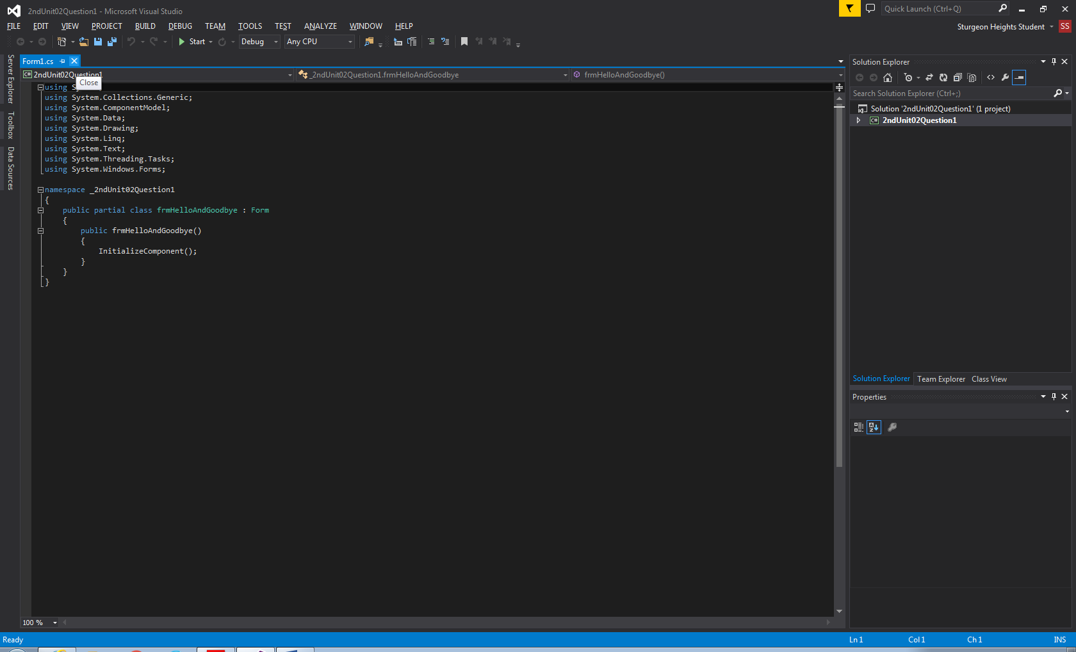

5. Go to the Properties in the Bottom Right Corner of the Screen to see where the file is!

